Web Development Assignment.

C15355361 – Ciara Sastre-DT282/1.

Here is my first thought process for what the website intended to look like:

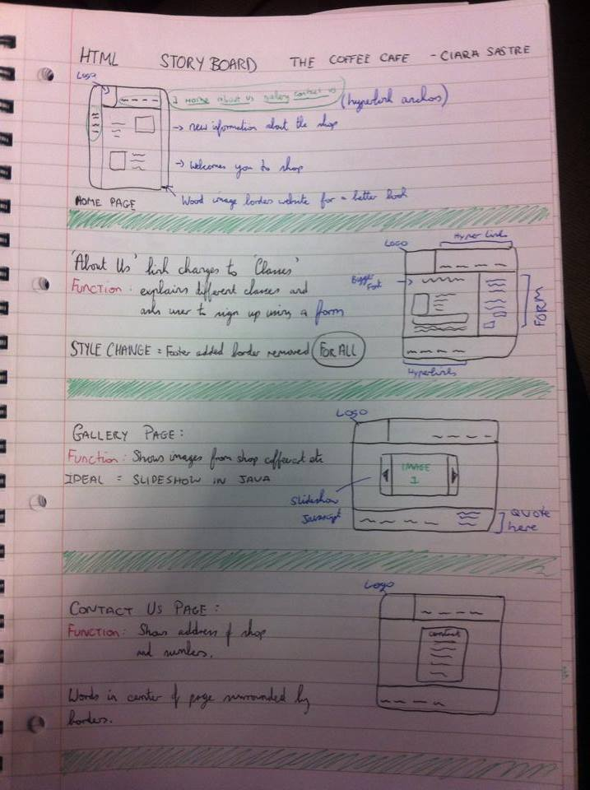

Here are the changes I then made to my website design and layout:

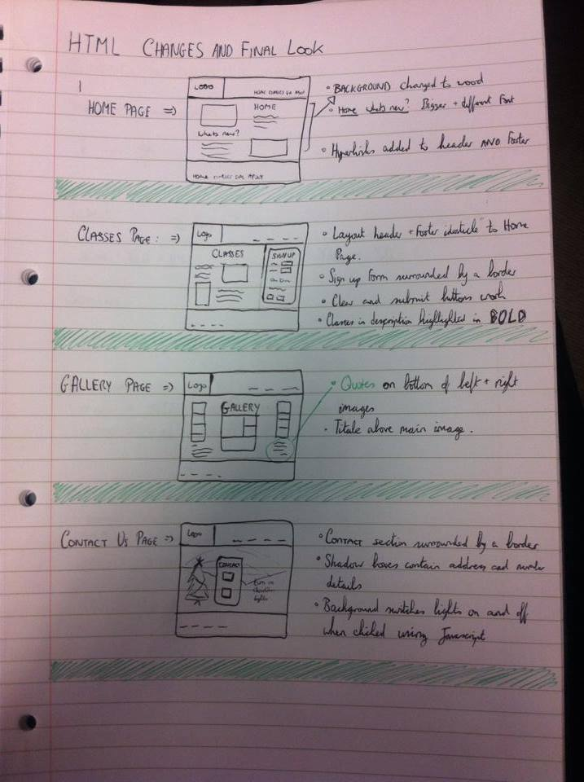

Nielsen’s heuristics:

The website I designed was for The Coffee Café.

The homepage is very welcoming and uses sombre colours like dark browns however the text is in a much lighter brown to create contrast between them and make the letters stand out. This is a great way to grab the user’s attention when they first visit your site.

I use short and to the point text so the user is not bored when reading and I incorporated a lot of images in my website.

The header has the coffee café logo in the top left corner on every page so the user is not lost and the header and footer are identical on each page for consistency.

The header has four clickable hyper links

* Home
* Classes
* Gallery
* Contact Us

When you hover over these their colour changes from black to grey this is so the user has more interaction with the website. This is also the same for the footer.

The CLASSES page has a table with all the different classes and their teachers smarty laid out on the bottom beside the “sign up” section this is to entice the user to want to sign up.

The sign up page is clear and very simple and it has a “submit” box and a “clear” box in case the user makes any mistakes.

The GALLERY page has loads of images which I had collaged together and at the bottom of each are “quotes” from different people who went to the store. This is so the user can read reviews and they can see if they like it or not.

The CONTACT US page was designed to be simple at first.

It has the address in a shadow box and on a different shadow box the numbers are displayed.

Because it’s near to Christmas I decided to incorporate an interactive background. So at the beginning the Christmas tree is dark and once it is clicked the Christmas tree will light up. This is a way to help the user engage with the website and also brings a very happy notion of Christmas into their heads.